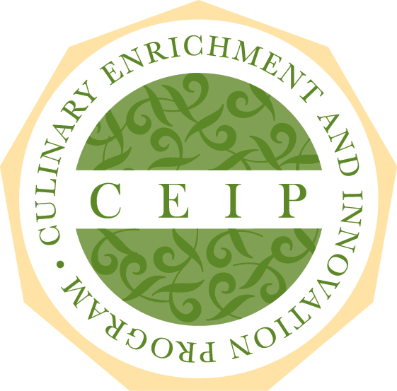
APPLICATION FORM

Thank you for your interest in applying to CEIP, the Culinary Enrichment and Innovation Program, a culinary leadership program from The Culinary Institute of America and Hormel Foods.

Application forms will be accepted September 1 – December 14, 2018.

Incomplete applications cannot be processed. You will receive a formal response to your application by email no later than January 7, 2019.

Please complete this application, scan and send to applications@ceipinfo.com.

PROFESSIONAL INFORMATION

Name (First, Last)

Email Address

Current Employer’s Name

Employer’s Address (City, State, Zip)

Employer’s Phone

Number of Years with this Establishment

Current Position

How Long in this Position

Responsibilities in Current Position

Supervisor’s Name/Title

Supervisor’s Contact Information

History of Culinary Professional Experience (past and present)

PRIOR PROFESSIONAL EXPERIENCE AND RESPONSIBILITIES

Please list experience related to your skill competencies, overall culinary responsibilities, supervisory or operations-related duties, training duties, menu development responsibilities, and specific areas of expertise or focus.

PROFESSIONAL BACKGROUND

Education (include degrees and formal/informal mentoring you received)

Professional Development Courses/Conferences Attended

Professional Certification(s)

Awards/Achievements

Memberships

ESSAY QUESTIONS

1. What career goals have you set for yourself?

2. How do you define “success” for your career?

3. How would your colleagues describe your personality and your creative vision?

4. Describe your greatest strengths as a chef and as a leader.

5. What has been your greatest professional challenge throughout your culinary career?

6. What do you hope to be doing in five years?

7. Who do you admire most in the food industry and why?

8. Who do you admire most outside of the food industry and why?

9. What are the greatest opportunities and challenges in the culinary industry today and why?

